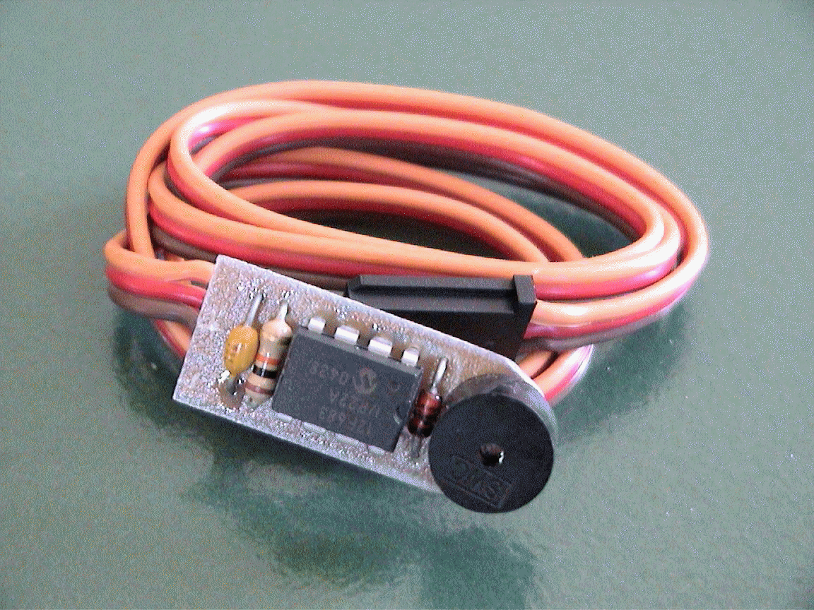
“AipAxe” R/C Switch
Operating Instructions

1. With both the transmitter and receiver powered off, plug the servo plug into the receiver channel # to which you want to use as your shutter control. This can either be a switch or joystick controlled channel.
2. Power up the transmitter first and position the switch or stick (corresponding to channel on receiver which switch is connected) in the direction to which you would want to be the OFF position (the position where no picture is taken).
3. Now power up the receiver and you will hear the switch and Aiptek camera eventually power up (beeps). About a second or two after that (as the circuit analyzes the receiver servo signal), you will hear a "Ready" beep (2 low beeps then a longer high beep) indicating that the circuit is ready for operation (no others beeps should be heard until you take a picture, or until the servo signal is invalid).
IS THAT SIMPLE?
4. To take a picture, move the joystick/switch to the ON position and then return it to the opposite (OFF) position. You should hear the switch circuit output a low to high chirp, and then quickly hear the Aiptek camera take a picture (also visible on the Aiptek display). If the transmitter's switch/joystick is left in the ON position, the switch circuit will make the Aiptek camera take a picture approximately every 7 seconds, until the switch/joystick is returned to the OFF position.
5. If you were to turn off the transmitter while the receiver and camera are powered up, the switch circuit will eventually continually beep, indicating that there exists no servo signal. This is the built-in "Model-Finder" alarm that will hopefully help you locate a downed aircraft. Just power off the transmitter and the circuit will begin to beep.
6. Upon powering up the transmitter, you will eventually hear a "Ready" beep (2 low beeps then a longer high beep) indicating that the circuit is ready for operation once again.
Additional Notes
- Aiptek cameras can be funny in that some are particularly sensitive to input voltage. Most Aiptek cameras I have modified work fine on 5V and even 5.5 volts. If you try to power up the camera from the receiver and the receiver is powered using 5 cells (6 volts), the camera will probably not turn on, and you in fact might damage the PIC switch circuit. Some work, some don’t. It is highly recommended that you power up the receiver/camera using either a 4 cell battery pack (4.8-5.2 volts) or use a Battery Elimination Circuit (BEC) or voltage regulator that outputs a regulated 5 volts.
- When you connect the camera up to your computer to download pictures (via USB cable), the camera and switch circuit are powered up. Because the switch circuit does not sense a valid servo signal, the model-finder alarm will beep continuously as you are downloading pictures. The download process is not affected by this beeping. Once the downloading is complete, simply unplug the USB cable.
- This mod originally was designed such that the camera could still be powered and operated with two AAA batteries. After modifying a bunch of these cameras, I have noticed that most work normally with batteries installed but few for some reason do not. I therefore can not guarantee that the camera will operate properly with batteries installed. The intention of this modification was to make an R/C controlled aerial camera using a miniature hand-help digital camera. I can guarantee that this mod will do just that!
- There has been rare occurrences where an Aiptek camera can simply go "berserk"...., i.e. continual beeping or just does not work at all (indicated some times by all "eights" (888) in the camera display). In this case, it is good to reset the camera by hold down the "mode" and "shutter" buttons simultaneously for several seconds until a beep is heard (do this while camera is powered up). Removing power for a few seconds and reapplying has some times fixed the problem too.
TRICKS! The AipAxe chip was originally designed to output a High-Z state when not triggered, but when trigger, the output pin is driven to 0v (or ground)... this ground is what triggers the Aiptek camera shutter switch. If you want the PIC's output to provide +5v when triggered, you can connect pin#6 to +5v (preferably through a 10K resistor). Normally on the camera switch PCB I sell, this pin is grounded by default.
Additionally, as designed, the PIC will toggle the output (from 0 to 5v or from High-Z to Ground.. depending on Pin#6 state described above) every 7-8 seconds. Upon being triggered, you’d have to wait 7-8 seconds to re-toggle the output. The PIC's pin#5 controls the delay of this toggle function... when grounded, you get a 8 second delay and when connected to +5v (though 10K resistor), you would have a 1 second delay.

Aipaxe Connections to Aiptek Camera
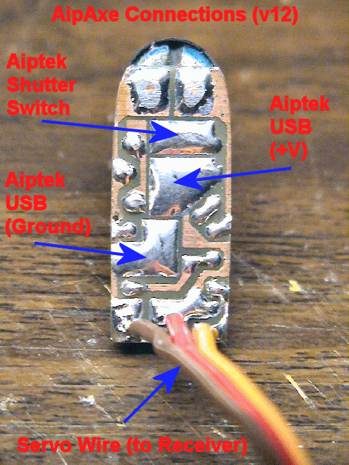

More info @ www.diyrc.com
SCHEMATIC & P.C.B.

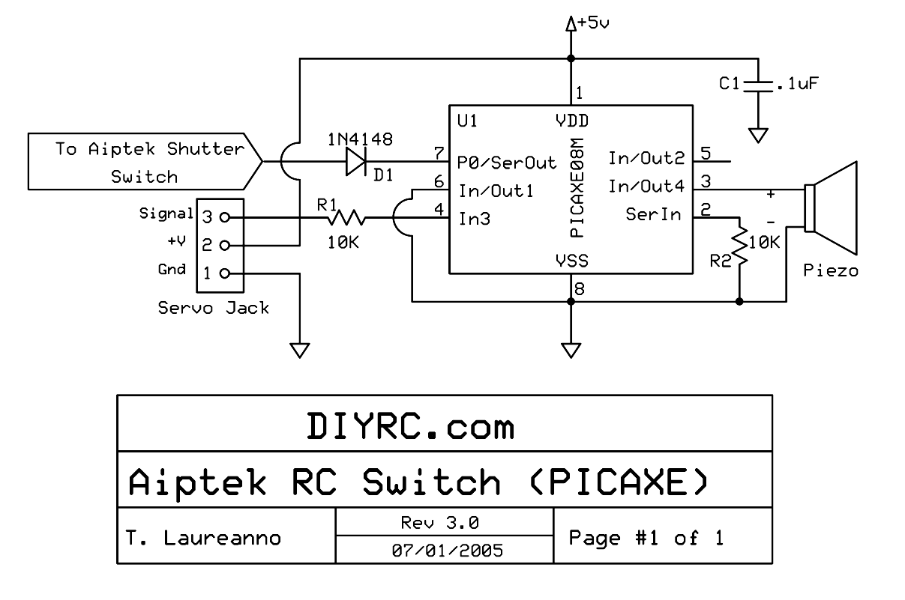
(Note: Also ground pin 5 by folding pin onto ground trace on PCB)

